- GENERAL RULE

NO | SECTION | RULE
1 | Title | Approximately 20 words
2 | Abstract | No more than 250 words
3 | Keyword | Maximum 8 keywords
4 | Main (Including: Introduction, Literature Review, Method, Result, Discussion, Conclusion, Limitation) | - words
5 | Bibliography

- ARTICLE TEMPLATES

TYPE YOUR ARTICLE TITLE [TIMES NEW ROMAN 14]

First Author¹
Second Author²,
and so on. (Times New Roman 12; single-spaced)
¹Affiliation of the first author (Institution/University, etc.)
²Affiliation of the second author (Institution/University, etc.)
*Correspondence: email of the first author (Times New Roman; single-spaced)

Abstract (Times New Roman 12)
The abstract content is written in Times New Roman 12 (single-spaced). The abstract includes: the main issue, purpose, method, any novelty), results, conclusions, and recommendations for future research. The abstract should be written in one paragraph, without references, abbreviations/acronyms, or footnotes. The abstract should not include mathematical expressions, yet clear enough for an informed reader to understand the manuscript’s contribution The English abstract must not exceed 250 words.

Keywords : Consists of 3 to 8 words and/or word groups, written in alphabetical order. Keywords are separated by semicolons (;).

INTRODUCTION (Times New Roman 12)
The main section of an article should start with an introductory section. The introduction includes the background, novelty, motivation and main issues of the study/research. The introduction should be relatively nontechnical, yet clear enough for an informed reader to understand the manuscript’s contribution The content is written in Times New Roman 12 (single-space).

LITERATURE REVIEW AND DEVELOPMENT OF A HYPOTHESIS (if any) (Times New Roman 12)
The literature review represents the theoretical core of an article. In this section, will discuss the purpose of a literature review. The literature review includes the scientific theories and concepts that serve as the basis for the study/research. References should be relevant to the topic, have state-of-the-art content, and be from the last 10 years. Every reference cited must appear in the bibliography. A literature review is a means to an end, namely to provide background to and serve as motivation for the objectives and hypotheses that guide your own research. A good literature review does not merely summarise relevant previous research. In the literature review, the researcher critically evaluates, re-organizes and synthesizes the work of others. Subheadings in the literature review are written in Times New Roman 12, with content in Times New Roman 12 (single-space).

Sub-title of literature review and hypothesis (Times New Roman 12)
The sub-title of the literature review is written in Times New Roman 12 font and the content is in Times New Roman 12 font (single space).

RESEARCH METHOD (Times New Roman 12)
This section includes: research design, population and samplng, data collection techniques, variable measurement and hypothesis testing. The method section reflects how the study's data is analyzed, resulting in findings and discussions. Content is written in Times New Roman 12 (single-space).

Sub-title of research methods (Times New Roman 12)
The sub-title of the research method is written in Times New Roman 12 font and the content is in Times New Roman 12 font (single space).

RESULTS AND DISCUSSION (Times New Roman 12)
Results and discussion are written in Times New Roman 12 (single space). Results should be separated from the discussion. Results are not raw data but processed/analyzed data using specific methods. The discussion interprets the data analysis, possibly linking it to relevant scientific theories or concepts in the literature review. This section must address the research problem and contribute to new knowledge. Results and discussions may include interpretations, tables, figures, diagrams, graphs, sketches, etc.

Table titles: Times New Roman 12; table content: Times New Roman 10 (single-space).
Figures: Continuous numbering (e.g., Figure 1, Figure 2). Must include sources if extracted from other references.

Table 1
Usage of Collections by Language (Times New Roman 10)
No | Description | Sum
1. | Number of property and real estate companies listed on the Indonesia Stock Exchange during 2013-2015 | 159
2. | Companies that do not publish their annual reports consistently and incomplete data | (12)
3. | Companies that were only listed in 2014 or 2015 | (15)
4. | Companies that were delisted between 2013-2015 | (6)
 | Number of companies studied in 2013-2015 | 126

Figures are arranged continuously, e.g. Figure 1, Figure 2, Figure 3, and so on. If the image is cited/taken from another source, the source must be included. These images include photos, diagrams, graphs, charts, sketches, prototypes, and databases.

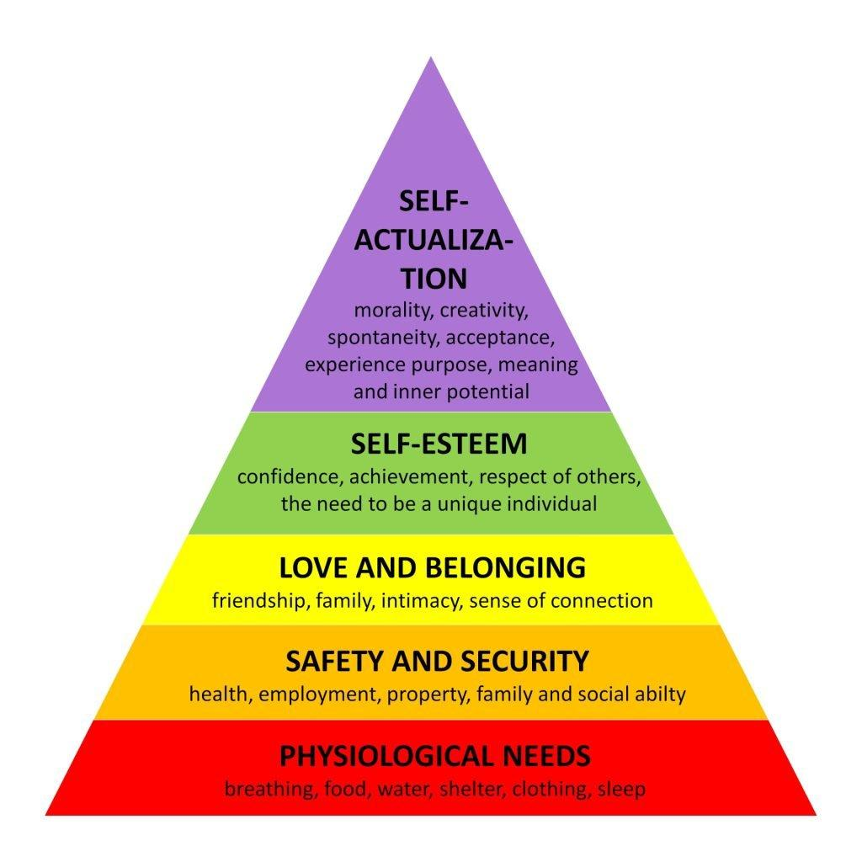
Figure 1.
Maslow's Hierarchy of Needs
(Source: Chalofsky, et al. 2014)
(Times New Roman 12)

CONCLUSIONS, LIMITATIONS, AND SUGGESTIONS (Times New Roman 12)

Conclusions (Times New Roman 12)
Content is written in Times New Roman 12 (single-space). This section summarizes the discussion results in one paragraph, without quoting theories.

Limitations (Times New Roman 12)
Content is written in Times New Roman 12 (single-space). This section summarizes the limitations faced during data collection and processing.

Suggestions for Future Research (Times New Roman 12)
Suggestions are written in one paragraph using Times New Roman 12 (single-spaced).

BIBLIOGRAPHY (Times New Roman 12)
The bibliography includes all references cited in the study/research. The references are written systematically (alphabetically) in Times New Roman 12 (single-space). The style follows the APA (American Psychological Association) 7th Edition format. Using automatic reference management tools like Zotero or Endnote is recommended. References should consist of a minimum of 10 scientific literatures (80% primary sources and 20% secondary sources).

Primary references: Journals, proceedings, research reports, theses, dissertations.
Secondary references: General books and reliable online scientific information sources.
Only references from the last 10 years are allowed.
Examples:

Amin, Muslim. Wan Ismail, Wan Khairuzzaman. Abdul Rasid, Siti Zaleha. Daverson, Richard. Selemani, Andrew (2014). The Impact of Human Resources Management Practices on Performance: Evidence from a Public University. The TQM Journal, 26 (2): 49-84
Fitzsimmons, James A. Fitzsimmons, Mona J. Bordoloi, Sanjeev K (2014). Service Management: Operations, Strategy, Information Technology, 8th Edition. McGraw.Hill International Edition 2014.

